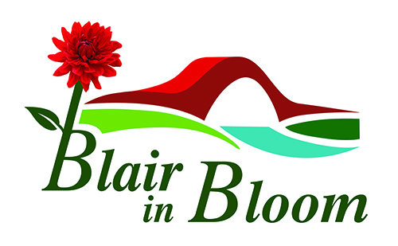

Minutes of Committee Meeting held on

5th June 2023

At The Rattray Community Garden at 6.30pm

1 | Those present: Cathy Doe, Pat Lumsden, Morag Reid, Jean Smith, Avril Wilson, William Wilson.
2 | Apologies from: Mary Birch, Cllr Bob Brawn, Cllr Caroline Shiers.
3. | Minutes of last Meeting. Approved byJean Smith Seconded by Avril Wilson
4.  5.  6  7.  8. | Matters Arising:  Bank Signatories still being processed. Bank to be rung to discuss.  Mural for Coronation Corner – ongoing  Victoria Community Garden Visit arranged for 8th July.  New email address to be looked at periodically and investigation as to whether groups can be set up on it to take place. Facebook page to be either transferred or a new page created. Refer to Steve at BRDT.  Treasurer’s Report:  Total in bank £2233.68  Form completed and returned to Tesco with regard to the £500 blue token scheme.  £540 from Plant Sale  Anonymous donation of £300  Approx £2500 income to come from hanging baskets  Possibility of blueberries again this year. Leslie to be asked.  Possibility of Pop Up Shop in Coupar Angus perhaps in October  Possible expenditure includes water consumption at Rattray Community Garden. Castle Water may give discount to charities which would include BRDT. To be discussed at Rattray Garden Management level  Vehicle Insurance approx. £300  Tractor, ATV and spare can all filled with diesel.  Tasks and Priorities - as attached list.  Projects:  A very good response to appeal for volunteers to help hang the baskets. This is happening on Sunday 11th June with rota to be advised.  Volunteers will be asked to help with watering baskets and again a rota will be made up for the next fourteen weeks or so.  Training will commence on 12th June with regard to driving ATV and equipment used to water.  Memorial Shrubs at Coronation Corner.  One shrub already planted and the other has now arrived. Donor has been invited to attend when shrub planted and will let us know.  AOCB:  An Extra Ordinary General Meeting is to take place on Monday 10th July at 2.30pm at Rattray Community Garden to appoint a new Chairperson of Blair in Bloom as Mary Birch has resigned due to ill health. A notice will be placed in the Blairgowrie Advertiser week commencing 12th June as required by the Constitution.  Jean and Morag attended Pride in Perthshire AGM and enjoyed their day. A great form to meet people from other Bloom groups.  Community Greeenspace Networking Group. Morag attended and found it very informative especially a presentation done by Charlie Hardman on Fundraising. There is lots off help out there should we wish to do our own fundraising and it is something that should be looked at more closely.  The Mushroom Trust and the Northwood Trust are options available to us and although the Mushroom Trust helped with finance for the new roof on the outbuilding we can apply again. It was advised Lottery Funding is very difficult as they alter their parameters too often.  An inventory of all our expensive and large equipment is necessary for insurance purposes and this is to be done shortly.  WI Talk Cathy and Jean to attend.  One of our volunteers has offered us a log splicer and we have gratefully accepted this kind offer.  Liquid fertiliser to be ordered for the hanging baskets.  Date of Next Meeting: Monday 3rd July 2023 at 6.30pm at 4 McLaren Park, Blairgowrie, PH10 6US | JS  PL/CD  JS  CD  MR  JS  WW  AW  JS  CD  WW  JS/CD  CD  WW

